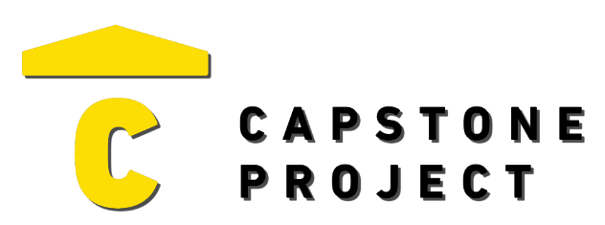
USER FEEDBACK
User Name: Antonio Bateman
What are your thoughts on the project overall?
The project seems well put together, testing environment connects to all servers without issue, website’s well designed and fleshed out with all features necessary for testing.

Was the project enjoyable? What was your favorite part of the project?
The project was quite enjoyable, testing process was simple, site had clear UI elements and had no problem in running scans from server to server.
What changes would improve the project?
I believe the project accomplished all it set out to do and cannot think of any improvements to give at this time.

Capstone Project Ratings:
Project Technology Depth (shows good usage of technology) | High
Project Breadth (number of features and content) | High
Professional Presentation (analogous to a real-world product) | High
Implementation Quality (number of bugs and errors) | Low
Project Completeness (project contains essential functionality) | High

Game / Application / Website Ratings:
Visuals (art style, environment, effects) | Very Positive
Audio (sound effects, music) | Positive
UI (title, menus, UI elements, text) | Very Positive
Controls (intuitive, ease of use, ease of navigation) | Very Positive
Interactivity (fun, engagement, flow) | Very Positive

